**CHAPTER THREE**

**MY INVOLVEMENT:**

My experience during my Industrial Training program at Federal Housing Authority was a diversified one;

It started from the experience gained in the office learning softwares and other theoretical aspect of Architecture to experience gained on site.

Experience Gained During Architectural Software Lesson Among I.T Students Includes;

1. Meaning of Architectural Software.
2. Types of Architectural Software.
3. Setting a page for Architectural Software.
4. Drawing using the application.
5. How to render the design for aesthetic and pleasing appearance

Experience Gained Doing Architectural lesson with Arch. Okpanachi Peter includes;

1. Site Analysis
2. Site Concept
3. Design of Duplex with a Penthouse
4. Cutting of section Experience Gained During During

Experience Gained On Site Include:

1. Preparing of wall for painting
2. Fixing of sanitary waves.
3. Types of tiles
4. Finishes

Experience Gained During Architectural software lesson

* During my industrial training, all architectural students under construction unit with me at Federal Housing Authority decided to be teaching ourselves on how to use Architectural software in designing building.

The lesson started by explaining to ourselves what Architectural software is,

Architectural Software’s are software’s which are used by Architect for designing building, modeling, rendering, and 2D construction documents.

**TYPES OF ARCHITECTURAL SOFTWARES**

1. Auto-CAD
2. Revit
3. Archi-CAD
4. V-Ray
5. Sketch-Up
6. Orion
7. Chief Architect
8. 3D Max
9. Rhino
10. CATIA

The report is based on Archi-CAD software.

Archi-Cad: This is a 3D architectural software used for designing building, modeling, and rendering Architectural works.

ArchiCad comes in version every year with improvement.

**Setting ArchiCAd Page For Architectural Work.**

1. Double click on the ArchiCad icon on the desktop to open the application.
2. In the dialog box, select create new project and click new to open to a page you are to work page.

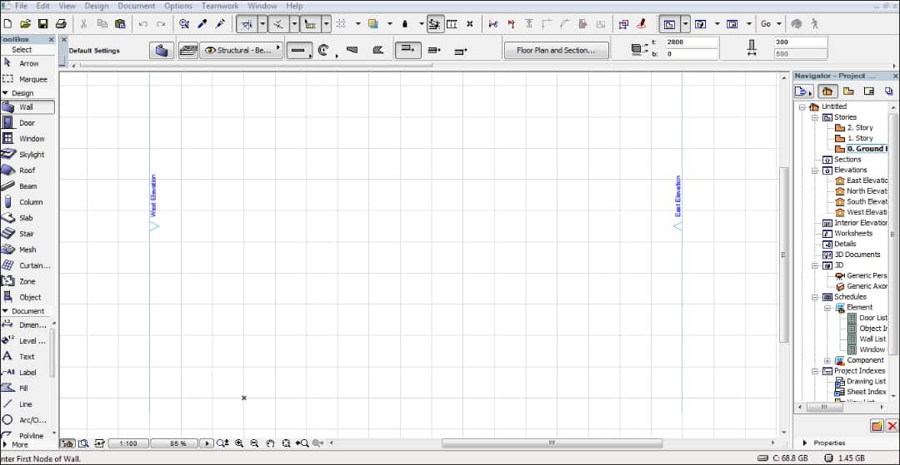

1. Change the scale to any scale of your choice by the bottom left side of the screen.
2. Change the height of your building and wall thickness by the topmost right side of your screen.
3. In the dialog box by the left side of your screen, you will see all parts of the building that you will work on to achieve a complete building design e.g wall, window, roof, slab, stair, skylight e.t.c
4. Pick any of the tools from the toolbox on the on the left side of your screen for the drawing of your building plan.
5. When you are done drawing your building plan, select window from the toolbox, a dialog box will open, select the type of window you want and edit the sizes and fix in the floor plan where necessary.
6. Select door from the toolbox and edit the same way you did for window and fix where necessary.
7. Select roof from the toolbox and go round the floor plan with the mouse pointer
8. Go to the dialog box on the right hand side of the screen and click on Generic Axonometry to view the building in 3D.
9. Go to document on top of your screen, a dialog box will open, then select creative image, a dialog box will open, select photorenter projection and double click on it to render your building.

Below is a complete design done on ArchiCAd software;

